**Term 2 - 2024**

**Biology Paper 3**

**Marking Scheme**

**FORM Four (4)**

**Time: 13/4Hours**

**Name**: ………………………………………..............**Adm No**: ……….…......

**Stream**: ………………**Candidate’s** **Signature**: …….……. Date: ….…

**School …………………………………………………………….**

**INSTRUCTIONS TO CANDIDATES:**

* *Write your* ***name*** *and* ***admission number*** *in the spaces provided.*
* *Sign and write* ***date*** *of examination in the spaces provided above*
* *Answer* ***all*** *the questions in this paper.*
* *You are required to spend the first 15 minutes of the 1¾ hours allowed for this paper reading the whole paper carefully.*

***For Examiner’s Use Only:***

|  |  |  |
| --- | --- | --- |
| **QUESTIONS** | **MAXIMUM SCORE** | **CANDIDATE’S SCORE** |
| 1 | 14 |  |
| 2 | 12 |  |
| 3 | 14 |  |
| **TOTAL** | **40** |  |

**1.** You are provided with 10cm3solution Q, a mixture of certain food substance, Iodine solution and Benedict’s solution. Using the provided labels identify two test tubes as A and B. Divide solution Q into two equal portions and place into the two test tubes labeled A and B.

a) Using the contents of test tube A, and the provided reagents, carry out food test hence fill the table below. (6 marks)

|  |  |  |  |
| --- | --- | --- | --- |
| Food substance | Procedure | Observation | Conclusion |
| *Starch* | *Put 2cm3 of solution Q in a test tube, add 3 drops of Iodine solution;* | *Blue black colour;* | *Starch present;* |
| *Reducing sugars* | *Put 2cm3 of solution Q in a test tube add equal volume of Benedict’s solution and heat to boil;* | *Blue colour of Benedict’s solution retained;* | *Reducing sugar absent;* |

*Observation and conclusion tied to procedure, penalize wrong sp of Benedict’s once under procedure but continue marking*

b) Add 3cm3 of solution N into test tube B then place in a water bath maintained at 300c for 10 minutes. Remove from the water bath and repeat the test in (a) above. Then fill the table below. (4marks)

|  |  |  |  |
| --- | --- | --- | --- |
| Food substance | procedure | Observation | Conclusion |
| *Starch* | *Put 2cm3 of solution Q in a test tube, add 3 drops of Iodine solution;* | *Brown colour of Iodine solution persists/ retained;* | *Starch absent;* |
| *Reducing sugars* | *Put 2cm3 of solution Q in a test tube add equal volume of Benedict’s solution and heat to boil;* | *Colour change from blue to green to yellow and finally orange/ brown;* | *Reducing sugar present;* |

(c) (i) Suggest the identity of N  (1mark)

*Starch digesting enzyme/ diastase/* *amylase; rej. Enzyme alone*

d) Account for the results in table for (b) above  (3marks)

*Diastase/ amylase ~~enzyme~~; break down/ hydrolyze; starch into glucose/ maltose/ reducing sugar; hence the presence of reducing sugar*

**2.** The photographs below show evidence of different structures that indicate evidences of evolution.

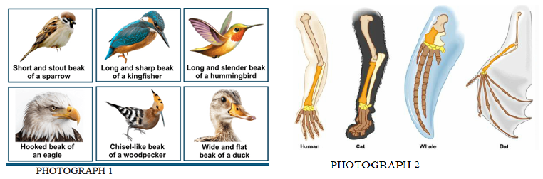

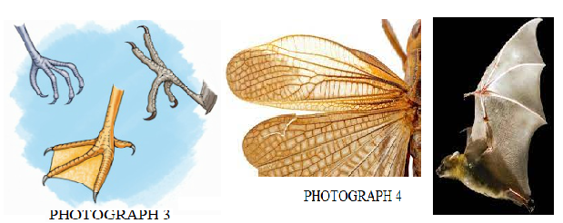

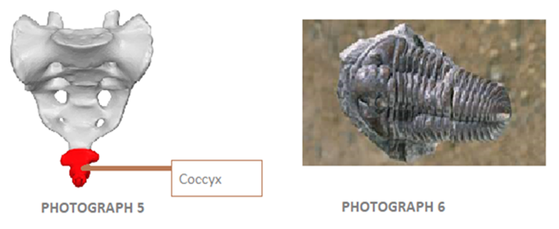

(a) Name the evidence represented by photographs 1, 2, 3 and 4.  (1 mark)

*Comparative anatomy;*

(b) Name the type of structures represented by photograph 4. (1 mark)

*Analogous structures;*

(c) Name the common evolutionary phenomenon exhibited by structures in photographs 1, 2 and 3.  (1 mark)

*Adaptive radiation;*

(d) (i) All the birds with the different beaks and feet shown above once had a common ancestor. Name the type of evolution shown by the emergence of the different beaks and feet many years later. (1 mark)

*Divergent evolution;*

(ii) Photograph 3 represents a webbed feet of a duck. Suggest how Lamarck would have explained the emergence of this type of feet. (3 marks)

*The ducks had a basic feet structure; the environment became aquatic and demanded swimming/ floating on water; ducks began to use the feet by stretching; webs developed between the feet digits as a result of stretching and this was passed on to the next generation;*

(iii) Photograph 6 shows a fossil of a trilobite. Trilobites are extinct. Suggest how Darwin would have explained the cause of their extinction. (2 marks)

*Variations arose randomly in trilobite population as a result of changes arising from internal factors; the variations were disadvantageous in the survival and exploitation of the environment of trilobites; (hence there are no organisms of that species alive today/ phased out of the earth’s surface)*

e) Name the organism that exhibits the evidence in photograph 5. (1 mark)

*Human beings;*

f) (i) Give two observable features that would help in classifying organisms in photograph 1 into their correct class. (2 marks)

*Body covered with feathers;*

*Presence of beaks;*

**3.** You are provided with specimen **M** and **N** obtained from two different plants. Take specimen M and carefully cut it longitudinally into two halves. Place a drop of iodine solution on each cut surface of the specimen. Leave it for two minutes then wash the cut surface with water. Repeat the same procedure with specimen **N**. Using a hand lens, observe the colour changes.

a) i) State observations in each case; **M** and **N**  (2 marks)

Specimen **M** *Stains blue black at the outer margin; with the central portion unstained/* *remaining white*

Specimen **N** *Stains blue black entirely/ whole surface;*

ii) Explain the distribution of colour on the surfaces of each specimen **M** and **N**. (2 marks)

*In* ***M*** *(maize grain) starch is stored in endosperm located on the sides/ periphery but not in the scutellum at the center;*

*In* ***N*** *(bean seed) starch is stored in the entire cotyledon;*

b) The photograph below illustrates the germination of specimen **N** after it was planted.

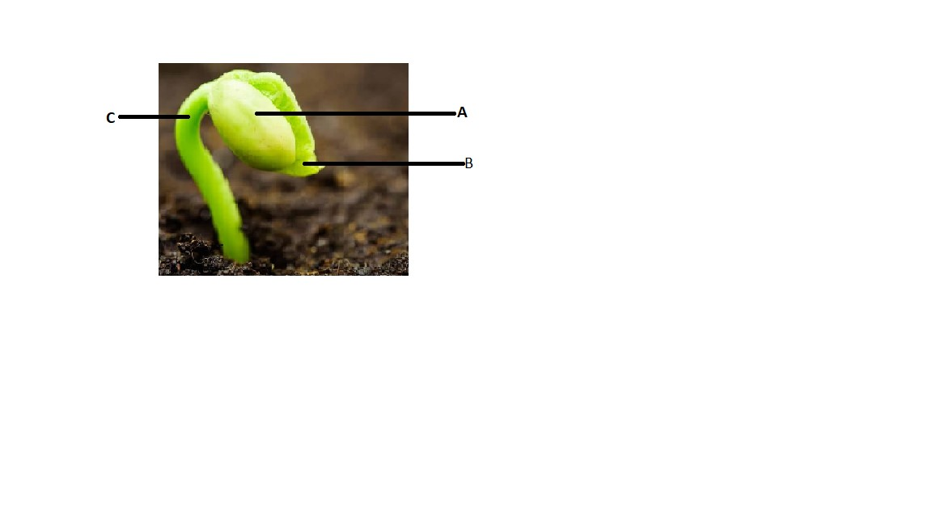

i) Giving a reason, identify the type of germination shown. (2 marks)

Type *Epigeal;*

Reason *Cotyledons are brought above the soil surface;*

ii) Name the parts **B** and **C**   (2 marks)

**B** *First foliage leaf/ leaves;*

**C** *Hypocotyl;*

iii) Give three roles of part **A** during germination  (3 marks)

*Site for photosynthesis before formation of the first foliage leaves*

*Site for hydrolysis of stored food for germination/ provide stored food for germination;*

*Storage of food for the embryo before photosynthesis begins;*

c) Explain how the part labeled **C** eventually straightens up after a few days of growth (3 marks)

*Exposure of part c/ hypocotyl to light; causes downward migration of auxins to lower side of the shoot; high concentration of auxins on the lower side of the curvature causes faster cell elongation/growth; (hence the straightening of the seedling)*